Task Report

SQL – AND, OR, NOT
In this scenario we need to filter data outputs with multiple conditions.
    - Retrieve after hours failed login attempts
    - Retrieve login attempts on specific dates
    - Retrieve login attempts outside Mexico (Where hot wings prevail)
    - Retrieve employees in Marketing
    - Retrieve employees in Finance or Sales
    - Retrieve all employees NOT in IT

Task 1.
Retrieve after hours failed login attempts

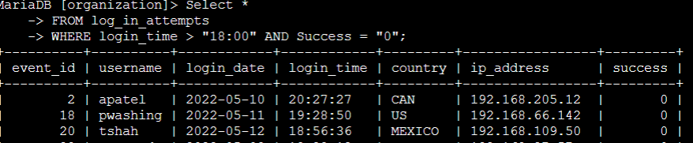

Command Semantics
    - SELECT *
FROM log_in_attempts
WHERE login_time > '18:00' AND success = “0”; This command tells SQL to output all columns FROM the log_in_attempts table WHERE login_times are after (>) 6pm AND the attempt failed (0).

Task 2.
Retrieve login attempts on specific dates

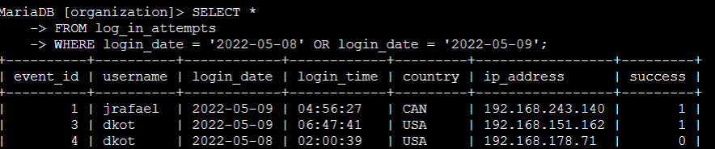

Command Semantics
    - SELECT *
FROM log_in_attempts
WHERE login_date = '2022-05-08' OR login_date = '2022-05-09'; This command tells SQL to output all columns FROM the log_in_attempts table WHERE login_dates are 2022-05-08 OR 2022-05-09
    - NOTE – the BETWEEN operator would work well here too.

Task 3.
Retrieve login attempts outside Mexico (Where hot wings prevail)

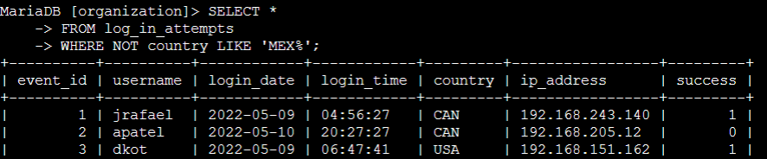
Various uses of the (%) operator
Pattern | Results
a% | apple123, art, a
a_ | as, an, a7
a__ | ant, add, a1c
%a | pizza, Z6ra, a
_a | ma, 1a, Ha
%a% | Again, back, a
_a_ | Car, ban, ea7

Command Semantics
    - SELECT *
FROM log_in_attempts
WHERE NOT country LIKE 'MEX%'; This command tells SQL to output all columns FROM the log_in_attempts table WHERE the login country was not Mexico.
    - Because outputs for Mexico vary after “MEX”, the (%) operator is used to ensure all entries with MEX and any character string following MEX are all included.

Task 4.
Retrieve employees in Marketing

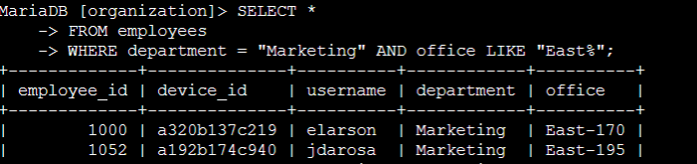
Command Semantics
    - SELECT *
    - FROM employees
    - WHERE department = "Marketing" AND office LIKE "East%"; This command tells SQL to output all columns FROM the employees table WHERE the department is “Marketing” AND the office building is any of the buildings starting with the string “East”

Task 5.
Retrieve employees in Finance or Sales

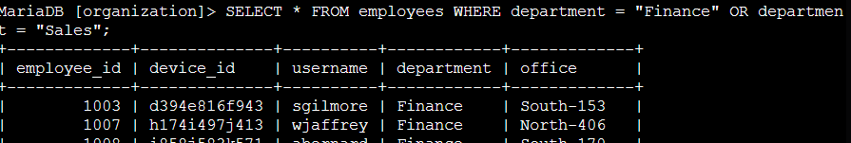

Command Semantics
    - SELECT *
    - FROM employees
    - WHERE department = "Finance" OR department = "Sales"; This command tells SQL to output all columns FROM the employees table WHERE the department is “Finance” AND “Sales”. The (;) ends the command.

Task 6.
Retrieve all employees NOT in IT

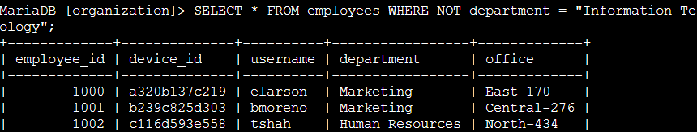
Command Semantics
    - SELECT *
    - FROM employees
    - WHERE NOT department = "Information Technology"; This command tells SQL to output all columns FROM the employees table WHERE the department is NOT “Information Technology”

Summary
We used the operators AND, OR, and NOT to filter information in SQL. This helped us learn how to gather data in an efficient way to do normal everyday tasks that result in a harder security posture. This way, we have protected out rights and our power to buy hot-wings, when we really need them the most. All can appreciate that, can't we?

